Oromia Forest and Wildlife Enterprise
Oromia REDD+ Coordination Unit

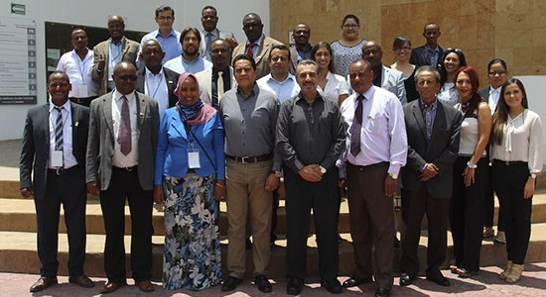

REDD+ Readiness Process and Sustainable Forest Management in Mexico
(Report on Experience Sharing Visit)

June 18-27, 2015

Contents
Acknowledgements 3
1. Introduction 4
2. Forestry Landscape in Mexico 5
2.1. Institutional Arrangement 5
2.2. Overview of Mexican Forest Sector 8
2.3. National Forest Program of Mexico 8
2.4. National Forest Inventory project 10
2.5. Fire Protection and Management Facility 10
2.6 Payment for Hydrological Environmental Services Program 10
2.7. Forest Restoration Program 11
2.8. Community Forest Management 11
2.9. Forest extraction 12
2.10. Forest Industry 13
2.11. Resin collection and production of adhesives 14
3. National REDD+ Preparedness of Mexico 15
3.1: Context 15
3.2. National REDD+ Program 15
3.3. National Program Activities 16
3.4. REDD+ Safeguards 16
3.5. Monitoring, Reporting and Verification (MRV) system for REDD+ 17
4. Lessons Learned 17
Annex 20

Acknowledgements
A number of individuals and organizations have contributed for the success of this visit. The study tour organizers on behalf of the delegation team are grateful of their service:
- CONAFOR (Comision Nacional Forestal, Mexico's Forestry Commission) - for accepting our request, for their warm hospitality, for planning and coordinating visit engagements and for generously sharing Mexico's lessons and experiences and for making our stay in Mexico memorable. Two individuals, Mr Jose Armando Alanis de la Rosa and Mrs Miriam Andreli Solis Hernandez at CONAFOR deserve special thanks for their company and serving us tirelessly.
- The National REDD+ Secretariat/Ministry of Environment and Forest - For arranging the visit and providing overall support

1. Introduction
Overseas experience sharing visit to Mexico was organized by the Oromia Forested Landscape Program (OFLP) from September 26 - October 3/2015. Thirteen participants from Oromia President Office (1), Oromia Forest and Wildlife Enterprise (5), Oromia Rural Land and Environmental Protection (1), Oromia Bureau of Agriculture (1), Oromia Bureau of Water, Minerals and Energy (1), Oromia REDD+ Coordination Unit (3) and National REDD+ Secretariat (1) participated in the event. The full list of participants, their institutional affiliation and respective positions is presented in the annex of this report.
The experience sharing visit to Mexican forest sector was organized with the support of the National REDD+ Secretariat, housed within the Ministry of Environment, Forest and Climate Change and the World Bank. The National Forestry Commission of Mexico facilitated and made all necessary arrangements to make the visit worthwhile.
Mexico was considered a suitable destination for the visit since it has similar social and bio-physical characteristic to Ethiopia. Specifically, Mexico has been selected for this exposure visit for a number of reasons:
- Mexico is one of the few REDD+ advanced countries (REDD+ early movers) with a lot of lessons and experiences on the challenges and opportunities of REDD+ readiness process.
- Mexico has a practical experience on implementation of Payment for Ecosystem Services (PES), a feasible scheme for the promotion of Sustainable Forest Management.
- Historically, Mexico had a high rate of deforestation (up to 600,000ha/yr in the south east) and Mexico's deforestation was driven by agricultural expansion and unsustainable fuel wood extraction. This has a parallel in Ethiopia as these divers are the current challenges in Ethiopia. On top of that, the country has got lessons (success and failures) from forest rehabilitation and development efforts.
- Mexico is a mountainous country like Ethiopia and forest development is intrinsically linked with ensuring sustainable land and water resource management which is the case in Ethiopia.
The objectives of the experience sharing visit to Mexican Forest Sector were:
- To obtain experience in the design and implementation of Emission Reduction Programs, including setting targets, monitoring, institutional and implementation arrangements;
- To obtain practical lessons and experiences with regard to implementation of sustainable forest management and forest restoration, including forestry industry functions;
- To obtain on-the ground experience of community led forestry activities;
- To get a first-hand knowledge and experience on preparation of Payments for forest Ecosystem services.

This report provides summary of the experience sharing visit in Mexico including that of presentations by host country and field visits.

2. Forestry Landscape in Mexico

2.1. Institutional Arrangement
The National Forestry Commission of Mexico (CONAFOR) is an institution within the Ministry of Environment and Natural Resources (SEMARNAT) responsible for design and implementation of national policies in the forest sector. Its main objectives are to develop, support and promote Mexico's forest conservation and restoration, as well as to design plans, programmes, and policies for sustainable forestry development.
Table: 1. Structure of the Federal Public Administration in Environment and Natural Resources
Ministry of Environment and Natural Resources
(SEMARNAT)
Regulation and coordination of national policy for protection, conservation and sustainable use of natural resources and environmental protection
National Forestry Commission (CONAFOR) | National Commission of Natural Protected Areas (CONANP) | National Commission for Use and Knowledge of Biodiversity (CONABIO) | National Institute of Ecology and Climate Change (INECC) | Federal Attorney for Environmental Protection  (PROFEPA)
Coordination of activities for conservation, protection and sustainable use of forest resources. | Management, protection and promotion of natural protected areas at the federal level. | Promotion and coordination of activities for increasing the knowledge and conservation of biodiversity. | Generation and dissemination of knowledge and information to support formulation of environmental policies to promote sustainable development | Enforcement of Environmental Laws and Regulations

Figure. 1: Organizational structure of National Forestry Commission (CONAFOR)

2.2. Overview of Mexican Forest Sector
Mexico is one of the five most biologically “mega-diverse” countries in the world, and its forests are home to 10 percent of Earth’s plant and animal species. The forest vegetation of Mexico is estimated at 138 million hectares, of which 66 million hectares is forest, and the rest is xerophyte scrubland and other types of vegetation. The vegetated and forest area represents 66% and 33% respectively of its national territory.
Of total forest area, 80 percent is social property (belonging to ejidos and communities), 15 percent is private property (small-scale landowners), and the remaining 5 percent is government property. Mexico is one of the few countries in the world in which property rights to forestlands were given to agrarian communities and ejidos following the revolutionary struggle of 1910. In Mexico, three types of property are recognized: communal property where communities (typically indigenous communities) own the territory; ejido property (a form which emerged out of post-revolutionary agrarian reform and which refers to propertyowners, ejidatarios, who received land grants for individual use, but under community administration); and finally, small property, which refers to privately owned forestlands.

2.3. National Forest Program of Mexico
Mexico’s ambitious National Forest Program (PRONAFOR 2014-2018) seeks to reverse the trend of deforestation (150,000ha/annum) and transform the forest resources into a competitive and socially inclusive sector, and thereby boost rural economies. The plan involves increasing areas of certified sustainably managed forest, as well as land under commercial plantation. Equally important, PRONAFOR seeks to increase payments for environmental services, and to improve the social and economic status of people living in forested areas, including by creating thousands of permanent jobs.
The five year's national forest program has five outputs:
- Increase forest production and productivity: This output seeks to increase the production of wood to about 11 million m³ by 2018: i.e, 9 million m³ of wood from natural forest and 2 million m³ from plantation forest. Figure 2 below provides the trend of wood production from Mexican forests. This would be achieved through increasing forest land use, commercial forest plantations and productive diversification and developing of markets and their relation with the forest industry (see figure...). By 2018, 2.5 million hectares of forest will be certified with different standards.

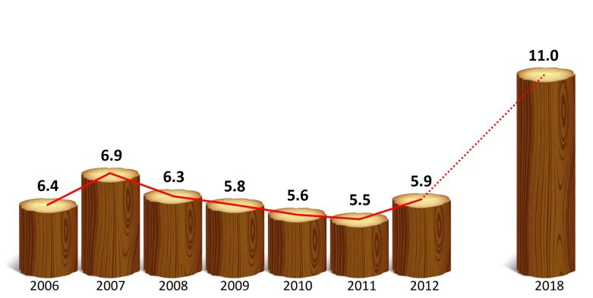
Figure 2: Trend of Mexico's wood production and projection under the National Forest Program
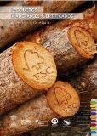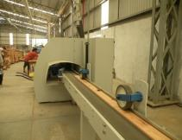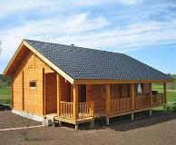
Figure 3: Markets and their relation with the forest industry
- Promote the conservation and restoration of forest ecosystems: This involves restoration or productive reconversion of 1 million hectares during the period 2014-2018. This will be conducted through improving forest germplasm and conservation of genetic resources and adopting Standards' certifications for forest nurseries.

- Protect forest ecosystems: Under this output PROFOR will encourgae and promote funds for the environmental services payment on 3.1 million hectares of forest by 2018.

- Promote and facilitate an enabling institutional framework for sustainable forest development
- Strengthen governance and the development of local capabilities

2.4. National Forest Inventory project
The objective of national forest inventory in general is to provide information on forest cover and functions which are necessary to support policies and decisions to conserve, protect and sustainably manage forests. Especially in countries like Mexico where forests are declining at a rapid rate, national forest monitoring systems capable of reliably estimating forest cover, forest cover change and carbon stock change are of vital importance.
CONAFOR is the responsable institution for implementing the national forestry project at the national level and promote implementation at the state level This project allows to have statistical and cartographic information of soil and forest ecosystems in the country to support the national policy of sustainable forest development.

2.5. Fire Protection and Management Facility
Wild fire is common in different parts of Mexico and Mexico has identified wild fire priority areas (101,43million ha high and medium priority areas). Wild fire is caused by a number of drivers including agriculture, hunting, festivals, rituals etc). While fire due to agriculture is the major cause, 98% of wildfires are caused by humans. The Sustainable Forestry Development Law of Mexico stipulates that Fire Management is a shared responsibility among CONAFOR, municipal government, state government, land owners and the Federation.
Mexico has a well-developed strategy for the prevention, detection, and suppression of wildfire activities. The strategic planning principle is to promote applied research in early warning system, moving from fire suppression policy toward fire management policy and strengthening international cooperation. There are 6 regional fire management centers which are aligned with the federal fire management center. A central fire management unit can monitor fire incidences and coordinate on ground actions with regional centeres. In general, Mexico has an advanced fire management system in the region.

2.6 Payment for Hydrological Environmental Services Program
Mexico faces many environmental challenges, being deforestation and water scarcity the two most important. The Payment for hydrological environmental services Program was designed by the federal government to pay forest owners for the benefits of watershed protection and aquifer recharge in areas where commercial forestry is not currently competitive. It seeks to complement the forestry and water policy by providing economic incentives to avoid deforestation in areas where water problems are severe.
The Payments for Ecosystem Services (PES) Program that the Mexican Government operates nationwide since 2003, is an effort that has preserved more than 3.2 million hectares of forest by providing direct compensations or incentives to more than five thousand landowners that voluntarily have decided to practice good land management activities.
The program has evolved along these ten years, trying to better suit the national conditions. Since 2008 the real users of the ecosystem services, including local governments, water utilities and private companies, got involved in the payments.
Monitoring consists in the analysis of high resolution multispectral images to calculate vegetation indices and the percentage of forest cover, and possible forest loss. Qualitative and quantitative variables from the National Forest and Soil Inventory and the Land Use and Vegetation map are also used. Monitoring activities are carried out by CONAFOR staff, at its headquarters and at the state offices.

2.7. Forest Restoration Program
The Forest Restoration Program established a new and innovative program in Mexico to provide grants for collaborative forest restoration projects on public land. The goal and objective of restoration in Mexico are to increase survival up to 70%, to reduce runoffs and increase rain water infiltration and to propitiate the conservation and sustainability of the basins. The strategies of forest restoration program includes identification of priority watersheds as a basic planning unit and the micro basin as operation unit, select areas with light and moderated erosion, with less than 20% coverage, reforest compact areas and prepare the ground with soil conservation works, to produce quality plant and appropriate species to the bioclimatic conditions of the country. The principal species used for restoration in Mexico most dominantly is Pines species because of the this variety of species are endemic to Mexico and helps to rehabilitate the degraded landscape.

2.8. Community Forest Management
Mexico has an excellent reputation of community based forest management. The delegation visited the forest enterprise of Indigenous Community of Nuevo San Juan Parangaricutiro (Purepecha) , located 15 Km east of Uruapan in the western part of the Mexican state of Michoacán. The forestry enterprise of San Juan, initiated in the early 1980s, is an important large-scale socially driven forest exploitation initiative in Mexico.
The indigenous group is made up of 7,500 community members (comuneros), which accounts for half the residents of Nuevo San Juan Parangaricutiro. The Indigenous Community of Nuevo San Juan Parangaricutiro seeks to preserve and defend its territory through community forestry and sustainable natural resource management. Two leading objectives of the community are: to increase economic benefits through sustainable natural resource management (and to distribute benefits fairly); and to create jobs for the local population (in part, to prevent out-migration).
The indigenous Purépecha community owns nearly two thirds of the municipal territory, which amounts to over 18,000 hectares of land, of which 11,000 hectares are forested. Communal land is zoned for different purposes: over 10,880 hectares are allocated for forestry, 1,200 hectares for forest plantations and nurseries, 1,931 hectares for agriculture, 2,122 hectares for fruit orchards, and 35 hectares for livestock pasture. A further 1,685 hectares are categorized as ‘rocky ground’ and 152 hectares as bush and shrub land.
The communal forest management system in Nuevo San Juan has received national and international recognition for its vertical integration of forest production (use of product and byproducts), its scale of operations, and its innovative management approach. The community has established a multifaceted social enterprise that sustainably produces timber, resin, furniture and other non-timber forest products.

In 1999, the community received certification from the Forest Stewardship Council (FSC), an independent organization devoted to encouraging the sustainable management of forests. FSC certification follows carries with it strict standards on forest management that ensure environmental and social responsible. Certification requires that the community’s forest management practices are audited on annual basis.

Today, the communal enterprise is active in more than twenty areas of production, the majority of which involve non-timber forest products. The delegation visited forest industrial facilities (sawmill, chipper, resin distillation, wood dry kiln, furniture and molding factory). It is the only communally owned enterprise in the State of Michoacán that has its own Department of Technical Forest Services, which ensures the enterprise is able to develop forest use and management plans that are aligned and harmonized with the Mexican Forest Law. The community forest based enterprises generates an average of 900 permanent and 300 temporary jobs each year, with total annual sales of USD 11 million.

2.9. Forest extraction
Forest management plan is a key part of the production process. No commercial harvesting legally occurs without management plan. The main objective of the management plan is to elaborate a program for the production of timber, which requires an inventory of the forest resource and a schedule of rotation over a given time period. Management plans frequently categorize the forest resource according to its commercial productivity, and areas for restoration, reforestation or conservation. The forestry management plans required to harvest in managed forest are integrated management plans, meaning that they address not only the commercial production of the forest and a forest inventory, but also the forest ecosystem as a whole, including its ecological services. The plans are required to specify that logging does not occur a certain distance from water courses or in critical areas (roads, sloped terrain, etc.), that area is set aside for protection of species, and that restoration in critical areas will be carried out.

One of the important features of community managed forest is that it is integrated. The logging and harvesting industry and forestry management (replanting and managing forests) feeds into the lumber and other wood products industries. At the same time, the byproducts from wood manufacturing provide inputs for the series of wood industry manufacturing.

2.10. Forest Industry
The forest industry comprises of sawn wood and lumber mills, impregnating plants, plywood mills, particle board plants, furniture manufacturing plants and resin-processing plants. The wood products industry is becoming more closely linked to wood products end user value chains, thus transforming it from a material supplier to a solutions provider. New types of business concepts are developed for the wood products industry and the prerequisites for product component suppliers are enhanced. New modification and surface forming technologies, composite products and structures, and integrating smart features in products and services updates wood products. Growing demand is concentrated not only on existing products, but also more advanced products and services. Another important feature is that most of the sector’s component parts are very capital intensive. Heavy equipment is used to harvest trees, which are then transported to sophisticated, high-tech manufacturing facilities.
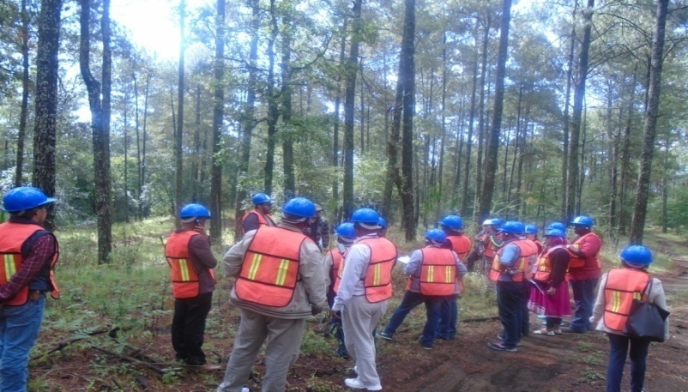

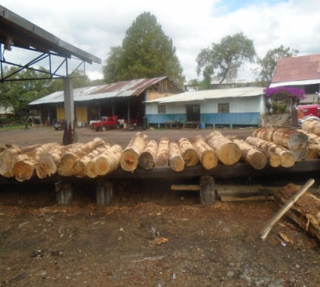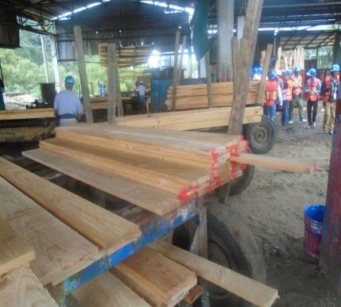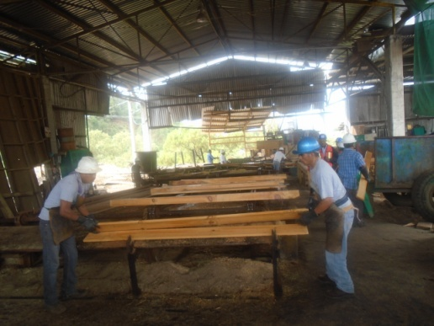
Figure 4: Delegation visiting community saw mill industry and harvesting operation (low impact logging)

2.11. Resin collection and production of adhesives
Resins from the pine spp. are harvested by a process known as tapping. Tapping involves removal of woody tissues up to 2m height of trunk without affecting tree survival and trees. Tapped trees are seen in the forest with old tapping scars that seem quite vigorous. It has been expained that if tapping is done properly, there is little or no injury to the tapped trees. According to the briefings from the company, trees can be tapped for over 20 years at 2 mt. height and this will open job opportunities for the local communities throughout the year.

Adhesives (important economic export commodities) manufacturing plant was one of the plant that the delegates paid a visit to learn what to do with the resins that have been collected from the pinus spp. stands forests. The resin is heated at very high temperature to refine it from residues. It passes through a series of stages at different chambers and eventually cooled down to form amphorous clean crystal. The clean crystal form resin is a raw material for the production of adhesives that is for domestic and export commodity.

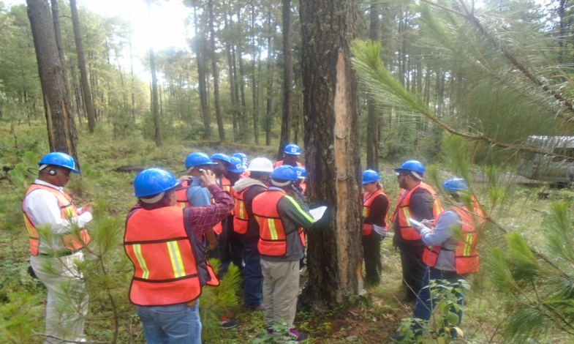
Fig 5. Forest technician explaining the tapping process

3. National REDD+ Preparedness of Mexico

3.1: Context
REDD+ in Mexico is considered as a vehicle for implementation of Sustainable Rural Development (SRD) which promotes a territorial and multi-sectorial approach, in order to reduce the pressures that lead to deforestation and forest degradation.
From 1990 through 2010, Mexico has tackled drivers of deforestation and significantly reduced the rate of deforestation. Mexico's vision on REDD+ is based on the diagnosis carried out for the forestry sector and recognizes that addressing deforestation and forest degradation. Mexico's Intentional Nationally Determined Contributions (INDC) to the UNFCCC in March 2015 indicates its commitment to reduce 25% of its emissions of greenhouse gases and short-lived pollutants by 2030 while maintaining deforestation and forest degradation related emissions neutral.

3.2. National REDD+ Program
The major objectives of the National REDD+ program is to address deforestation and forest degradation and thereby reduce GHG emissions through implementation of sustainable practices aimed at Sustainable Rural Development and conducive to improve living conditions of forest owners and users in rural areas.
REDD+ planning and implementation in Mexico is taking place at the national level, with sub-national and local projects nesting into the national approach. Mexico has produced a comprehensive REDD+ strategy with three components: actions to specifically meet the needs of forests and climate change; Program of REDD+ Early Actions and Low emissions activities. The presentation further outlines REDD+ Early Actions under implementation which includes:
- Develop and strengthen capacities of different sectors and actors.
- Develop replicable and scalable models on integrated landscape management, as platforms for local governance options.
- Integrate different activities into sustainable rural development.
Selection of priority sites for early action implementation was based on a clearly defined criteria. The national REDD+ strategy preparation involved a continuous consultation and participation of multi-stakeholders based on a communication strategy and a consultation plan. The consultation process has 3 phases (information/fact fishing, consultation/advisory and systematization of feedbacks) and the process has been successfully implemented in 32 different 32 different states across Mexico.
About 50% of the budget to run the 43 different programs is covered by CONAFOR and additional financial support is also provided by developmental partners. The basis for payment for PES is calculated from the opportunity cost of the forest (i.e. the opportunity cost associated if 1ha forest is converted to 1ha corn field). This cost usually ranges from USD 35 - 100/ha/year and payment depends on the type of ecosystem (i.e. ecosystem with high biodiversity or hydrological value get the highest pay than ecosystems with lower ecological significance).
REDD+ process started at the end of 2010. The major reason for an extended process is the broad consultation and participation of all relevant stakeholders/actors that REDD+ requires. The consultation and participation process involved a wide range of stakeholders at different administrative and sectoral levels. For example the national REDD+ strategy has been under consultation for the last two years and it has been consulted with different federal sectors and those in the 32 states of Mexico.
The two most important challenges for future REDD+ implementation are unemployed youth and woman and free grazing which REDD+ need to address.

3.3. National Program Activities
The work of certifying good forest management practices were done with a financial support from FAO since 2013. Good forest management practices are identified and are evaluated for certification.
Through a top-down approach, the decree for the National Forest Program implementation obliges sectors to align their policies and plans with the forest program. A series of discussions with different actors were conducted to create an environment for better coordination. Second, territorial (equivalent to sub-national level) level discussions were initiated by Public Territorial Development Agency to identify the needs of local people and harmonize programs accordingly.

3.4. REDD+ Safeguards
The design of REDD+ National Safeguard system for Mexico underlines the effective application and compliance with the safeguards and principles stipulated in the strategy and the legal framework of the country. The components of the National Safeguard System (NSS) are crosscutting theme of the draft National REDD+ Strategy in order to ensure their application and compliance. Accordingly, the following principles and measures are stippulated in the National REDD+ strategy to guide the successful implementation of safeguards:
- Institutional Arrangements and Capacity Building
- Public Policy and Legal Framework
- Communication, Social Participation and Transparency
The following series of actions and steps has been identified to advance the design and implementation of the National Safeguard System (NSS) in Mexico.
- Promote a process of participation and communication during the design and implementation of the NSS.
- Identification and analysis of the legal, institutional and compliance frameworks
- Definition of REDD+ Safeguards in Mexico
- Define the architecture and operation of the NSS – inputs from analysis to determine
- Determine how the NSS and the SIS will operate between the national and state levels
- Designing the structure and operation of the Safeguards Information System (SIS)

3.5. Monitoring, Reporting and Verification (MRV) system for REDD+
Mexico's REDD+ MRV system outlines the components of the national Forest Monitoring system, the IPCC requirements, the context of the approach and inter-institutional arrangement. The process of establishing Mexico's MRV system started in 2011 with the support of Norway, UNDP and FAO. Mexico uses Tier 2 in assessing its activity data and determining emissions factor. The process of MRV system establishment aspires to build the national capacity and generated lessons through engaging research institutions. Mexico's activity data combines 4 time-series (1993, 2002, 2007, and 2011) for land use land cover change. Mexico has advanced in its REDD+ Readiness and accomplished its international commitments. Readiness activities also improved monitoring of national mitigation targets and the country is now a reference in Forest Monitoring across Latin American countries.
- According to Mexico's forest definition, land with no livestock and/or water is considered as forest. For REDD+ MRV purposes, we adopt a forest definition which includes woody plants, shrubs including grasslands and shrubs having 30% cover.
- They combine two series satellite data to detect forest degradation. A historical change is captured with Land Sat 7 and Rapid Eye Sensors are used to detect changes after 2011.

4. Lessons Learned
The lessons drawn from the indigenous community forest management experience in Mexico show that local communities have key impacts in the conditions of the forests. The development of incentives, the strengthening of collectivities and local rule are imperatives for forest sustainability. In Mexico there is an important body of experience that shows the viability local stewardship of resources and ecosystems of high public value. The sustainability of community forestry in Mexico requires the support of both well crafted policies and markets able to recognize and value environmental and social costs.

What is unique about the Mexican case is the large number of communities that are managing common-property forests for the commercial production of timber, as well as finished timber products. At the same time, community forest enterprises (CFEs) are showing a capacity to make the transition to more competitive international markets while taking new measures to maintain forest productivity, biodiversity, and forest cover in their communities.

The Mexican case also demonstrates that community can create social capital, in creating job opportunities for local communities in the area of forest enterprises. Social capital may be defined as a flow or investments made in organizational and institutional processes by individuals or groups that enhance economic competitiveness. Social capital is based primarily on the concept of trust between individuals and groups of individuals, so that they may organize themselves for economic goals.

The Mexican experience is also based on the large scale transfer of natural forest assets, which could then be mobilized as natural capital with the historic creation of the CFE sector. The process of agrarian reform stemming from the Mexican Revolution led to as much as 80% of Mexican forests being in the hands of local communities have suggested four strategies for increasing the value of natural forest assets for the rural poor: investment, redistribution, internalization. The agrarian reform and forest policy processes in Mexico have featured aspects of the first three of these strategies with the agrarian reform process itself representing redistribution, followed by internalization, increasing the ability of the poor to capture benefits flowing from natural capital they already own through the creation of the CFE sector, and investment, which has been done by the communities themselves with profits from their CFEs.

The magnitude of the Mexican achievement in community-managed forests, and the highly significant strides toward generating income and maintaining forest cover and associated ecological services may be the exception that proves the hypothesis that communities who are given the opportunity to manage their own forest resources will play a key role in maintaining sustainable landscapes. In an era when timber production from natural forests is declining, wise use of policy and incentives by the Mexican government could possibly position Mexico’s forest sector as a high-value provider of niche markets from sustainably managed community forests, delivering both income and biodiversity protection.
In general the best practices captured during the visit that could be adaped to Oromia/Ethiopia case include:
- Well planned, organized forestry activities by forest agency, strong linkages among partners and stakeholders is very crucial for forest sector development.
- An excellent Inter-sectoral Coordination is essential to deliver REDD+
- Strong and reliable reforestation program would help in to reverse the trend of deforestation and forest degradation
- A modern and model nursery management practice that could be adapted to Ethiopia/Oromia case
- Modern wildfire management practice is important to control fire hazard
- Putting in place payment for environmental services system scheme would benefiit forest dependent communities and contributed to forest conservation
- Sustainable forest harvesting and modern logging system, forest product diversification and a well developed forest industry would help maximize the contribution of the forest sector in local economy
- Mexico's REDD+ Strategy development was highly consultative and participatory
- Mexico has a comprehensive forest inventory program which is an essential tool for decision making and planning process.

Annex
List of Visit Participants
Name | Institution | Position | Email address
- Mr. Getu Gemechu | Oromia President Office | Advisor to the President and Technical focal point of OFLP | gemechugetu@gmail.com
- Mrs. Habiba Siraj | Oromia Bureau of Rural Land and Environmental Protection | Deputy Head | habiba.siraj@yahoo.com
- Mr. Wirdy Hashim | Bureau of Water, Mineral and Energy | Bureau Head, Member of OFLP Steering Committee | worsesh@yahoo.com
- Mr. Didha Dirriba | Oromia Forest and Wildlife Enterprise | Director General, OFWE | birqinesh@gmail.com
- Mr. Abebe Wolde | Bureau of Agriculture | Process Owner, NRM | abebe4seb@yahoo.com
- Mr. Ararsa Regassa | Oromia Forest and Wildlife Enterprise (OFWE) | Deputy director General | ararsaf@gmail.com
- Mr. Fikadu Tefera | OFWE | Senior PFM Expert | fteferra@gmail.com
- Mr. Kedir Ninno | Arsi Branch, OFWE | Branch Manager | horakedir@gmail.com
- Mr. Batu Meskalu | Finfinne Branch, OFWE | Branch Manger | tesfaye.gonfa@yahoo.com/  fike_lege@yahoo.com
- Mr. Lemma Kitila | Wollega Branch, OFWE | Branch Manger | lemmakitila@yahoo.com
- Mr. Tesfaye Gonfa | Oromia REDD+ coordination Unit (ORCU) | OFLP Program Coordinator | tesfaye.gonfa@yahoo.com
- Mr. Taye Dugessa | ORCU | Social Safeguards Officer | taye_dugassa@yahoo.com
- Mr. Fekadu Legesse | ORCU | Environmental Safeguards Officer | fike_lege@yahoo.com

Ejidos are communally managed agrarian villages acting as self-organised legal entities that have been granted collective land holding by the state.
the name refers to the destruction of the original San Juan Parangaricutiro during the eruption of the Parícutin volcano in 1943

