OROMIA ENVIRONMENT, FOREST AND CLIMATE CHANGE AUTHORITY
OROMIA FORESTED LANDSCAPE PROGRAM

Minutes of Experience Sharing Visit to Humbo Assisted Natural Regeneration and Bale Eco-region projects

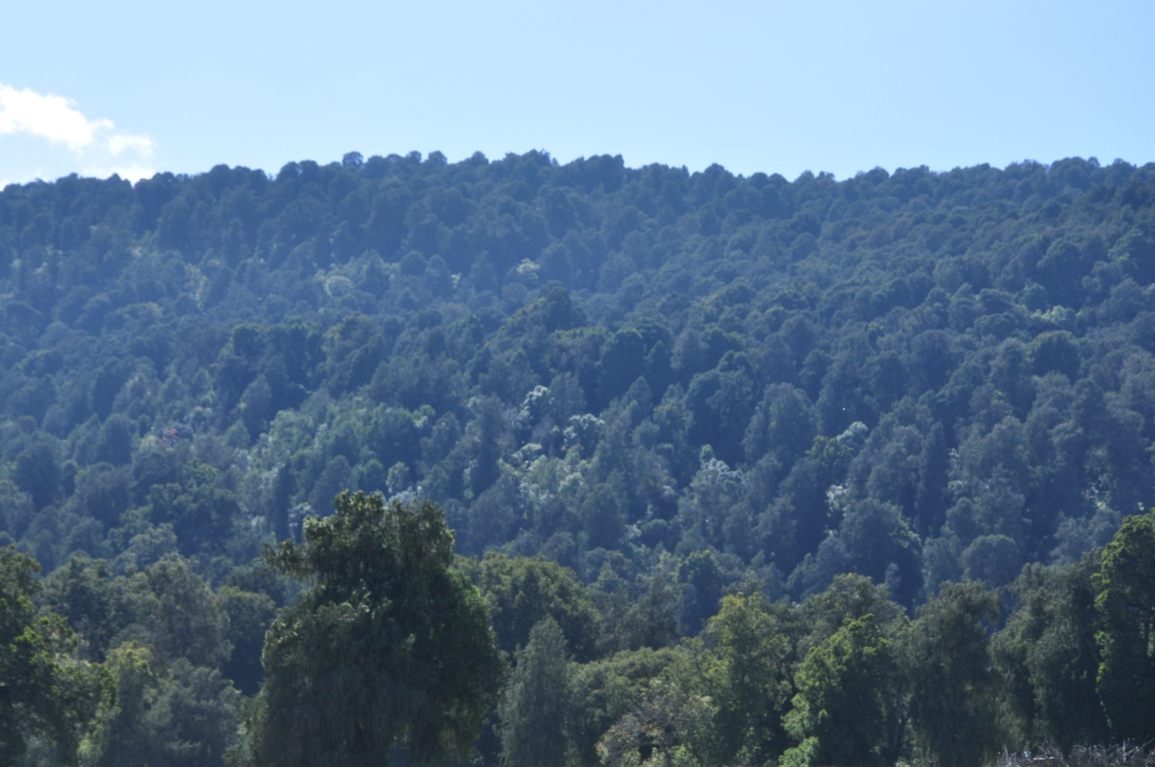

March, 2017
Finfinnee
Contents
1. Background 3
1.1 Introduction 3
1.2 Objectives of the experience sharing 3
2. Session1. Welcoming and Official opening of the meeting 3
3. Session 2: Presentation on overview of the OFLP: 4
4. Session 3: Questions and answers 6
5. Session 4: Presentation on Humbo Assisted Natural Regeneration Project 7
6. Session 5: Questions and answers 10
7. Session 6: Humbo Assisted Natural Regeneration Project Site Visit 12
8. Session 7: Questions and answers 13
9. Session 8. Bale ECO-region REDD+ project Site Visit 13
10. Session 9. Question and Answers 14

1. Background

1.1 Introduction
The Oromia Forested Landscape Program (OFLP) is a partnership between the Regional State of Oromia and the Ministry of Environment, Forest and Climate Change. OFLP is multi-sector in its very nature so it involves cross-sectoral interventions that demand strong institutional coordination at multiple scales. The Oromia REDD+ Coordination unit, housed in OEFCCA, is established to create such coordination during the design and implementation of the Program. Furthermore, the REDD+ Steering Committee and the Technical Working Group for Oromia were established to provide the ORCU with strategic and technical advice respectively.
To realize the objectives of OFLP, it is mandatory to empower and equip all relevant stakeholders with required knowledge/skill by organizing exposure visit to similar projects/programs in order to enable them to acquire lessons to be implemented in the context of OFLP. This experience sharing visit is planned to create awareness among stakeholders of Oromia Environment, Forest and Climate Change authority both at regional and zonal level and make all on board with respect to Oromia Forested Landscape Program implementation. This enables them to lead the program (OFLP) in well-organized and successful manner.

1.2 Objectives of the experience sharing
The overall objective of the experience sharing visit was to expose relevant stakeholders (OEFCCA management staff at regional level and Head of OEFCCA from each zone) to real project implementation outcomes of assisted natural regeneration, REDD+ project to draw lessons learned in the course of project implementation that will be used as an input for effective implementation of Oromia Forested Landscape Program.

2. Session1. Welcoming and Official opening of the meeting
Ato Tesfaye Gonfa has introduced the agenda of the visit to the participants. In his speech he was explain the issues discussed on the conference of parties from Stockholm to present, evolution of CDM and REDD+ in Oromia and call all participants for self introduction and Ato Ararsa Regassa for well coming and opening remarks. Accordingly all participants were introduced themselves.

Deputy Director General of Oromia Environment, Forest and Climate Change Authority Ato Ararsa Regassa made welcoming notes to all participants. In his speech, he was clearly explaining the importance of exposure visit to the newly established authority, the design and the implementation readiness of OFLP including financial grant from different donors. He was also explain that Humbo Assisted Natural Regeneration Project is the first in Africa in the history of carbon trade and that is why Humbo was visited by National and International body. The similarity and difference between CDM and REDD+, the scope of REDD+ and BSM were addressed. In his final speech he thanked all the participants for their esteemed and came to these important exposure visit and World Vision on behalf of the government and participants for their cooperation to organize this important visit.
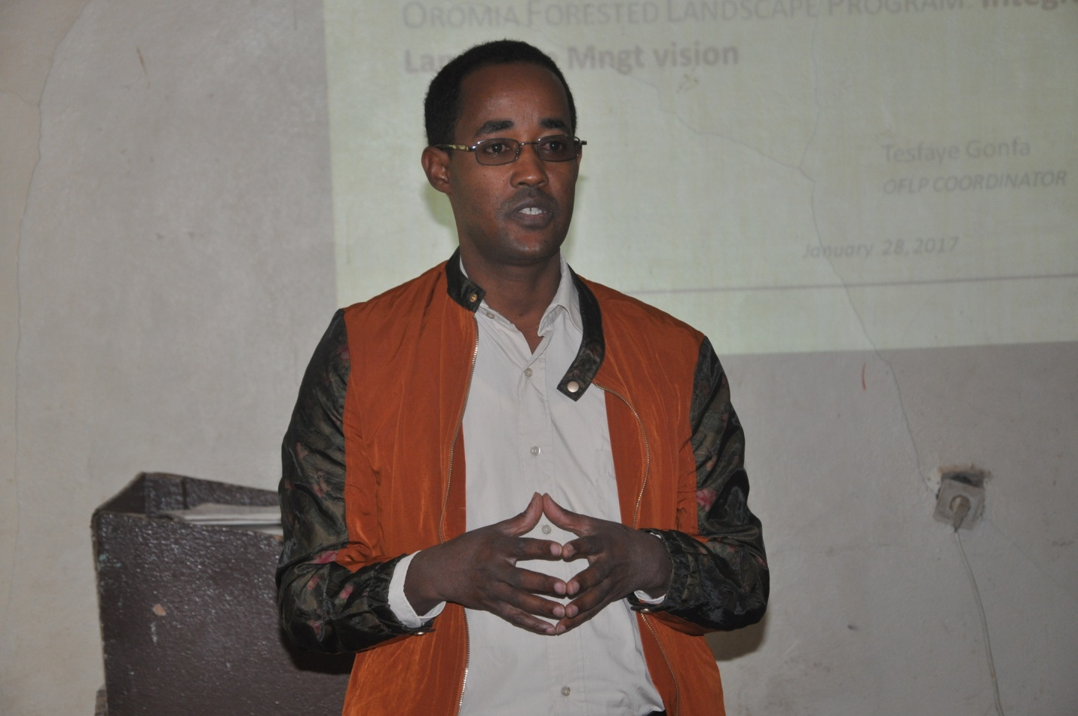
Fig: 1. Well coming and opening remarks by OEFCCA Deputy Director General

3. Session 2: Presentation on overview of the OFLP:
The major topics of presentation covered by Ato Tesfaye Gonfa (ORCU program coordinator) include:
- The concept of REDD+;
- The development agenda of Ethiopia (GTP2, CRGE and National REDD+);
- GHG process and photosynthesis concept;
- The role of forest in climate change mitigation;
- Phases of OFLP;
- Key design features of OFLP;
- OFLP as scale up engine;
- OFLP preparation and timeline;
- Scope of OFLP;
- OFLP interventions to address the main drivers of deforestation;
- Program Components and Activities and
- OFLP implementation arrangement.

In general during his presentation he was clearly explain the five components of REDD+ (Reducing Emission from Deforestation and Forest Degradation, Conservation of forest carbon stocks; Sustainable management of forests and Enhancement of forest carbon stock) to all participants.
The international Political negotiations and decision around climate change were clearly presented. Oromia Forested Landscape program objectives clearly introduced to the participants. Background of Oromia Regional State in terms of land mass, forest resources and REDD+ potentials were addressed in his presentation. The three phases of the program: Design phase, implementation phase and emission reduction phase was clearly presented by Tesfaye Gonfa (ORCU program coordinator). As he was clearly addressed a series of analytical study has been conducted and consultations were held at different level (regional to local level) for relevant stakeholders drawn from different institutions and local communities during the design of the program.
In his presentation he was also explain strategic fit of OFLP to regional and national strategies (GTP2, CRGE, National REDD+ and existing REDD+ relevant initiatives in Oromia). The scope of the program based on landscape and jurisdictional approaches to meets donors interest and others (International national and regional) was presented.

Program components and activities to be included in the OFLP program such as Enabling investments (Land use planning at district and community levels, Extension services, Forest management Investment in deforestation hotspot districts), Enabling environment (Institutions, Incentives, Information, Safeguards Management and Program Management) and Emission Reduction Payment were clearly presented.

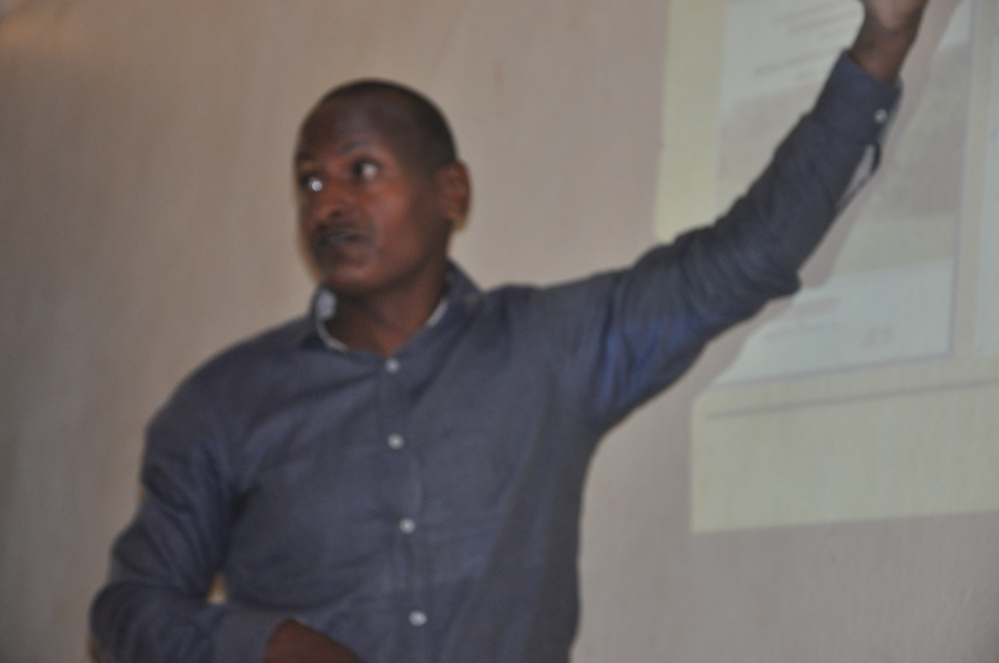
Fig 2: Presentation on Overview of the OFLP by ORCU Program Coordinator

4. Session 3: Questions and answers
- Why Jimma, West Arsi and Bale zones excluded from Deforestation hot spot area?
Answer: Although, they are not identified as deforestation hot spot areas that does not mean there are no deforestation in the three zones. The deforestation hot spot area (Guji, Kellam Wollega, West Wollega and I/A zones) was identified through two times satellite image detection and criteria set by experts drawn from OFWE, ORCU, MEFCC and individuals hired by MEFCC. Some of these criteria are Forest resources, potential carbon stock, deforestation rate relatives to others and Vegetation type. Bale zone was excluded because of the same intervention was carried out by FARM AFRICA for the last four years and may be maintained in the future.
- How do you handle the involuntary resettlement within OFLP?
Answer: From the perspective of OFLP safeguards instrument which was disclosed by the government on MEFCC website, involuntary resettlements is not allowed. That means involuntary resettlements is triggered to WB policy and OFLP safeguards instruments.
- How do you govern coffee management in the natural forest in REDD+ strategy?
Answer: During different analytical study had been conducted, it is identified as coffee management in natural forest contributes to forest degradation and biodiversity loss. Even if, OFLP does not account forest degradation in emission reduction payment coffee management is not allowed because of environmental issues (Biodiversity loss) triggered in OFLP safeguard instruments and WB polices.

5. Session 4: Presentation on Humbo Assisted Natural Regeneration Project
During this session a brief presentation on the background, goals, objectives, major interventions, GRM and challenges during the implementation of the project was made by Ato Tesfahun Eyoel (CC and EP coordinator of the World Vision). He was explain that Humbo assisted natural regeneration project is located in SNNPR, Wolayita zone, Humbo district 420 km away from Addis Ababa and it was started in 2005. In his presentation he was indicates the project is implemented by World Vision Ethiopia and funded by the World Bank Bio-Carbon Fund and the project covers 2,728 hectares of degraded forest which have been gradually restored and is sustainably managed by local communities. It is the first of its kind in Africa and Ethiopia to restore the degraded natural forest and generate carbon credits.

As a brief presentation was made by Tesfahun Eyoel, the project area before the intervention was open for fuel wood collection, charcoal and timber production, overgrazing, illegal resettlements and agricultural expansion. This over exploitation of forests led to shortage of firewood, soil erosion, and flooding, large gully formation, loss of biodiversity, reduced land productivity and Water depletion.
Goal of the project
- The main goal of the project is to sequester carbon in bio-diverse native forests & contributes to alleviation of poverty through the flow of benefits in to the area of health, education & food security from sell of Carbon credit, forest & non forest benefits.
The following steps were followed by the project during the design and implementation phases
- Community mobilization
- PDD preparation
- Operation monitoring plan
- Legal and Institutional analysis
- Social mitigation action plan
- Project coordinates
- Fire management plan
- ERPA
The following project participants: Communities, FBO & CBO, Government at all level, private sectors, World Vision Ethiopia, World Vision Australia and World Bank, livestock owners, wood collectors, charcoal makers, and hay collectors were recognized in the Humbo Assisted Natural Regeneration Project. The major interventions in the project detailed by the presenter are: Community consultation, building commitments at community and government at different level, organizing into cooperatives, communal land user right certifications, registration & legalization, benefit sharing, experience sharing visits and trainings, capacity buildings, delineation, stratification & monitoring plot and forest management practices.
General Information and status of Humbo and Sodo
Humbo | Sodo
- Expects to sequester 880,295 tons of carbon dioxide (t CO2)  - Project lifetime of 30 year crediting period  - 2728 hectare  - 5 Strata  - 85 Permanent Sample plot  - 3 Nurseries were established & > 1.7 million Seedlings Produced  - 247 hectare established plantation  - The BioCarbon Fund of the World Bank signed an ERPA in 2009 for 165,000 tones of CER’s.[1t=4.4USD]  - So far sold a total of 89,612 t CO2.  - 23,392tCOs expected  - 357,447.05 USD received | - Expects to sequester 189,026 tons of carbon dioxide (t CO2)  - Project lifetime of 35 year crediting period  - 503 hectares  - 3 strata  - 53 Permanent Sample plot  - 5 Nurseries were established & > 1.3 Seedlings produced.  - 32.5 hectare established plantation  - The Gold Standard and the CarbonFix Transition Guidelines.  - signed an ERPA in 2012 for First round 50,000 tCo2 CER [1t=9USD]  - So far sold total of 6,157 tCO2e  - 41,559 USD received

The benefits (environmental, social and economic) of the project were clearly presented by CC and EP coordinator of the World Vision. The Environmental benefits obtained from the projects are conducive habitat for wildlife, restored natural habitats, conserved biodiversity, improved genetic pool & medicinal plants, decreased downstream soil erosion & flooding, improved microclimate and improved agricultural production are clearly indicates during the presentation. Besides Environmental benefits social benefits like user rights of communities secured, community institutional capacity increased, promote good picture of the nation in the world, Increased working culture, center of experience sharing area and women and children saved their time.
Economically the project provided the following benefits: Generate income from the visit, carbon payment received and assets created, carbon revenue investment share within the union, credit service for more than 128 HHs in placed, income from seed collection increased, land productivity increased, temporary employment opportunity created and income generation from honey & mill service increased.
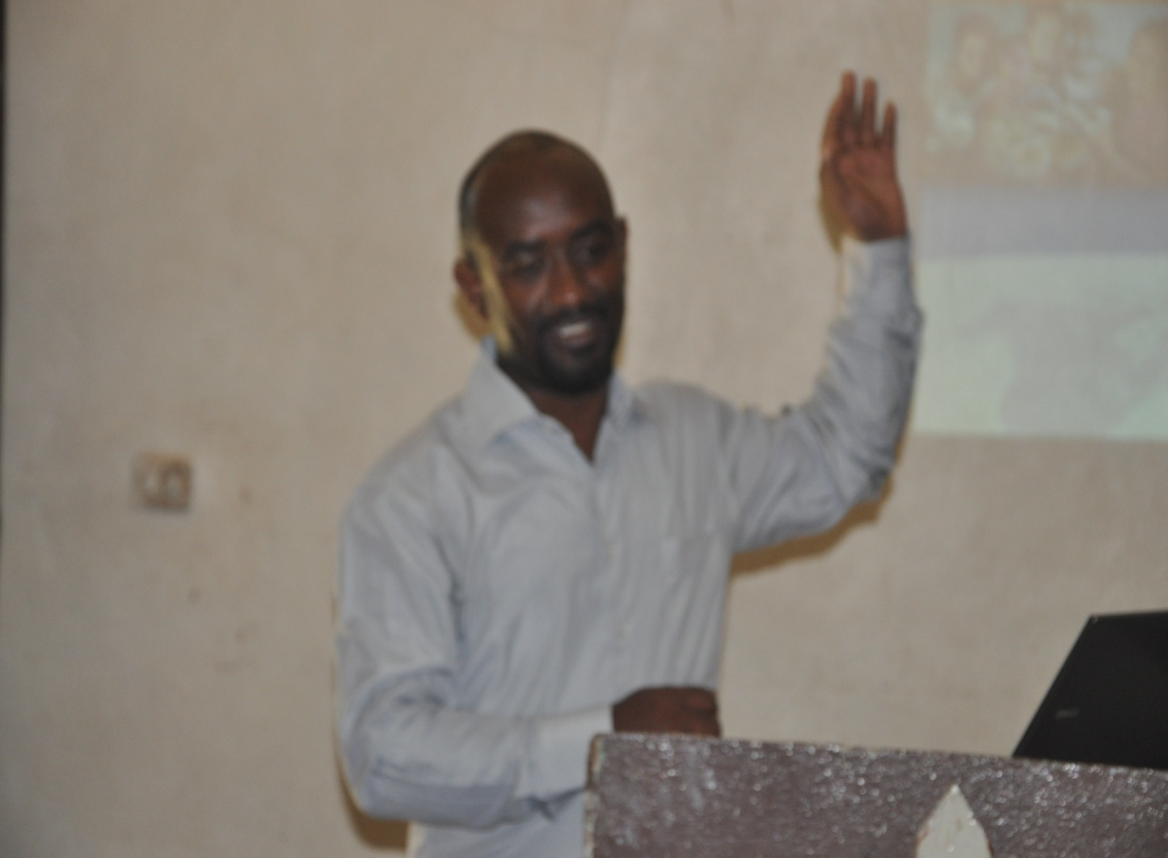
Fig 3: A brief presentation on Humbo Assisted Natural Regeneration Project

6. Session 5: Questions and answers
- Is there any communities excluded from CBO members?
Answer: No local communities are excluded from CBO members. The non members are those who are far from the forest.
- What kinds of BSM are there?
Answer: Each CBO's receive carbon benefit proportional to their forest area. The government does not have any share from the carbon payment. I.e. 100 % of payment goes to the; local communities.
- What are the roles of the government during the design and implementation phase of the project?
Answer: The government at different level plays a significant role by providing training in different topics to build capacity of the local communities. These enable the communities to manage forest resource, administer finance and assets in proper manner. Strengthen law enforcement; communal land user right certifications, regular supervision, registration & legalization are the support provided by the government.
- What is the total investment cost of the Humbo CDM project?
Answer: The initial investment cost was about 260, 000 USD donated by world vision Australia. This cost covered training, capacity building, livelihood improvement, A/R, etc during the first 3-4 years period.
- How did you bring the communities to the common interest?
Answer: Based on the need assessment was made during the design of the project the interest of the local communities was listed, prioritized and brought to common interest. Especial attention was given to solve the problems of women's and youth.
- Is there a CDM project replicate to other areas?
Answer: Although the CDM project is not replicate by the government and other NGO's , it has been expanded to Hadiya and Kembeta by World Vision Ethiopia and some CBO's who are interested by the project are submit their proposal and role map.
- Why agreement is not directly made between WB & Communities?
Answer: Because most of the activities were already handle by the World Vision Ethiopia and the agreement was made during the design phase as a project requirement. But currently most of the activities carried out by the local communities and the second phases might be handled/agreed between WB and local communities.
- How do you address the issues of Biodiversity in Project?
Answer: Promotion of native vegetation and biodiversity in the project area, which can be utilized as a shelter for local and migratory species and to improve the connectivity of fragmented forest resources are the main goals of the project. Any activities carried out by the project are biodiversity friendly i.e. Eucalyptus is not promoted, enrichments plantation promoted, natural regeneration encouraged and A/R is only allowed in open areas.
- Which Carbon pool is considered in Humbo CDM project?
Answer: From the six carbon pool it was agreed to consider the aboveground live tree pool. It is also under investigation to consider soil carbon in the future.
- How do you decide species preference in the project during A/R?
Answer: During afforestation and reforestation species preference was based on the need assessment carried out during the design of the project. Fast growing and environmental friendly species are considered as requirements.

7. Session 6: Humbo Assisted Natural Regeneration Project Site Visit
During this session Ato Beyene Agiwo, Union head welcomed the participant to Abala Longena cooperative project and the project has 1043 ha of forest. The union was established in 2005/06 and has 5089 members. Before the interventions by the project problems like soil erosion, rainfall scarcity, scarcity of fuel wood, decline of production and productivity are clearly addressed.
In his presentation the overall achievement of the project like forest rehabilitation, land productivity improved, grinding mill, improved livelihood, revolving fund, store, capacity building, income from seed collection, carbon payment and income from share holders were indicated.
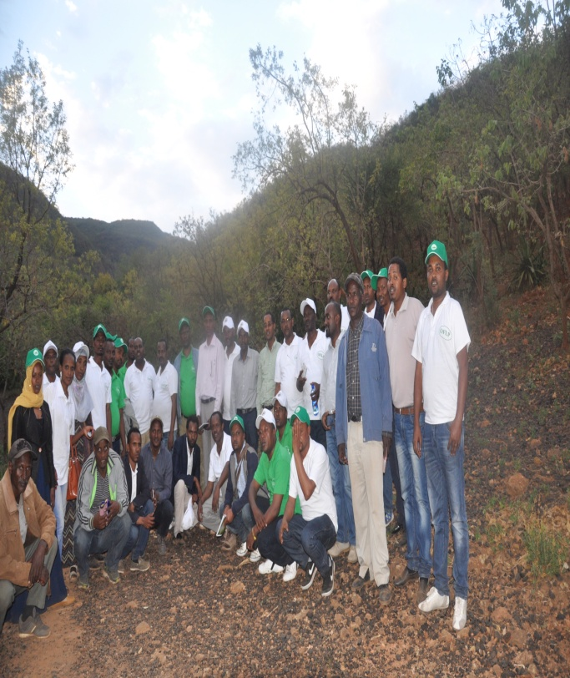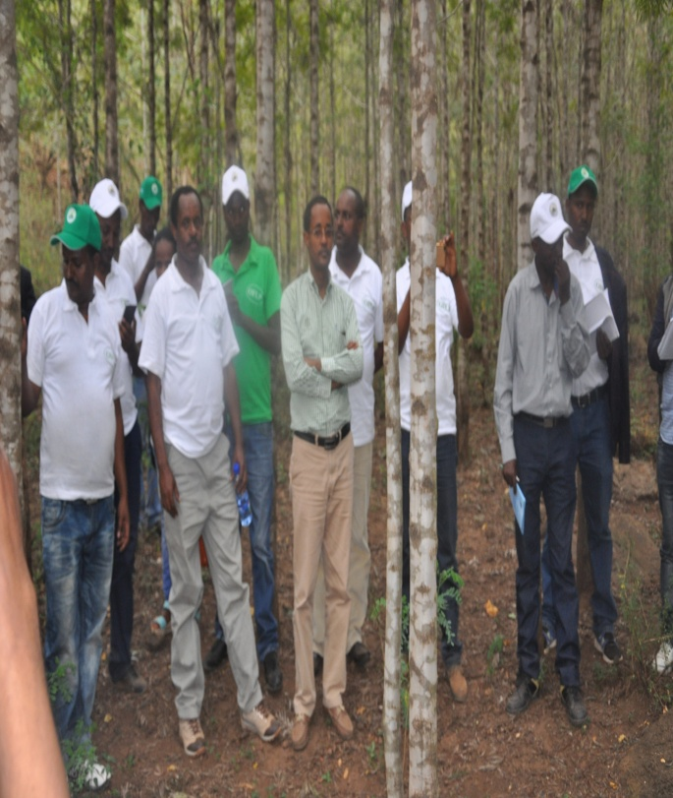
Fig 4: Humbo Assisted Natural Regeneration Project Site Visit

8. Session 7: Questions and answers
- If carbon payment is not maintained, how do you manage forest resources in sustainable manner?
Answer: The local communities already understood and benefited from non-carbon benefits of the forest and the capacity built and awareness created so far by the project assists to protect forest in the sustainable manner.
- What is the CBO's plan in the future?
Answer: To generate additional income and to protect forest in sustainable manner the CBO's together with union prepare annual work plan which include building/hole-block manufacture.

9. Session 8. Bale ECO-region REDD+ project Site Visit
A brief presentation on the background of the PFM and Bale ECO-region REDD+ project was made to the participants by Ato Ahimad Mohammad, Adaba Doddola OFWE District head. In his presentation he was explain that as OFWE is one of the government development enterprise established with the objectives of to protect and conserve forest and wildlife and to increase forest coverage in Oromia. Adaba-Doddola district covers four woreda (Kokosa, Adaba, Doddola and Nansabo) where Bale eco-region REDD+ project has been carried out and is implemented by the Oromia Forest and Wildlife Enterprise and NGOs Farm Africa and SOS Sahel Ethiopia with the objectives of building the capacity of local communities to sustainably manage land and forest resources in the Bale Eco-Region. In his presentation the preparation of documents like PDD preparation and reference level at project and CBO level, and other efforts so far made by FARM AFRICA was addressed. In his final presentation, currently the cooperatives jointly manage forest concession areas with OFWE through legally binding agreement and benefit sharing was set as 60% to community and 40% to government. As a result forests are protected and regeneration enhanced, provide shelter for wild life, income from the wild life, forest and non forest product increased.
The next presentation was made by Ato Kamal Umer, Manager of Farachu Raya forest union. In his presentation he point out GTZ is the first international NGO to implement PFM in Adaba-Dodola area in the late 1990s with the objective of promoting sustainable management and conservation of forest ecosystems and improving the livelihood of people living in or around the forest. The role of forest resources in supporting the livelihood of local communities, facts of CBO, boundaries of the project and history of PFM and Bale Eco-region REDD+ project clearly addressed during the presentation. The activities like Aforestation/reforestation (A/R), Enrichment plantation, regeneration Enhancement, training and capacity building, livelihood improvements through generating income from forest and non forest product and legal hunting, forest entrance, and share holders were clearly presented. After the intervention the positive impacts like attitudinal change, livelihood improvement, forest protected and income generated has been observed. During this success lack of commitments (communities and government at different level), lack of capacity and weak law enforcement are among the challenges enlightened by union manager.
The final Presenter Ato Huseen Roba, community representatives made a brief presentation by explain the history of PFM in Adaba-Doddola and the problems like severe deforestation due to agricultural expansion, illegal logging and weak law enforcement and different benefits obtained after the intervention by government and NGO's.

10. Session 9. Question and Answers
- How do you plan to overcome the problems you faced?
Answer: so far it is not promising.
- Why the CBO's is not produce honey in increase their income?
Answer: The productivity of honey is low in Adaba-Doddola area because of microclimate of the area. Even though the productivity is low, the local communities produce honey via traditional honey bee production system.
- What are the efforts so far made by OFWE to crate job opportunities?
Answer: The efforts like discovery of tourist area, livelihood alternative upon agro-climate, generate income from non timber forest products and others have been carried out.
- What has been done to generate income from fattening?
Answer: Although their productivity is not appreciated some of the local communities are exercise breeding and fattening.
- What has been done in strengthen law enforcement to reduce deforestation?
Answer: A big efforts has been done by OFWE, CBO's and Union to tackle the challenges at different level. Some of these efforts are awareness creation to relevant stakeholders including the local community, providing training to legal body and relevant sectors woreda and in placed bylaws.
- How do you replace the CBO members?
Answer: Yet not done but it is a big assignment to be treated.
List of Participants
